Introduction：

In this paper, we focus on diffeomorphic image registration highlighting with a set of critical features利用一组关键特征对图像进行高亮配准

1. captures large deformations
2. the topology of objects in the image remain intact
3. no non-differentiable artifacts

existing problems：

**the training process is extremely slow and memory intensive** due to the high dimensionality of deformation parameters in imaging space. In addition, **enforcing the smoothness constraints of transformations** when large deformation occurs is challenging in neural networks.

To the best of our knowledge, we are the first to introduce **the low dimensional Fourier representations of diffeomorphic transformations** to learning-based registration algorithms

Method，network：

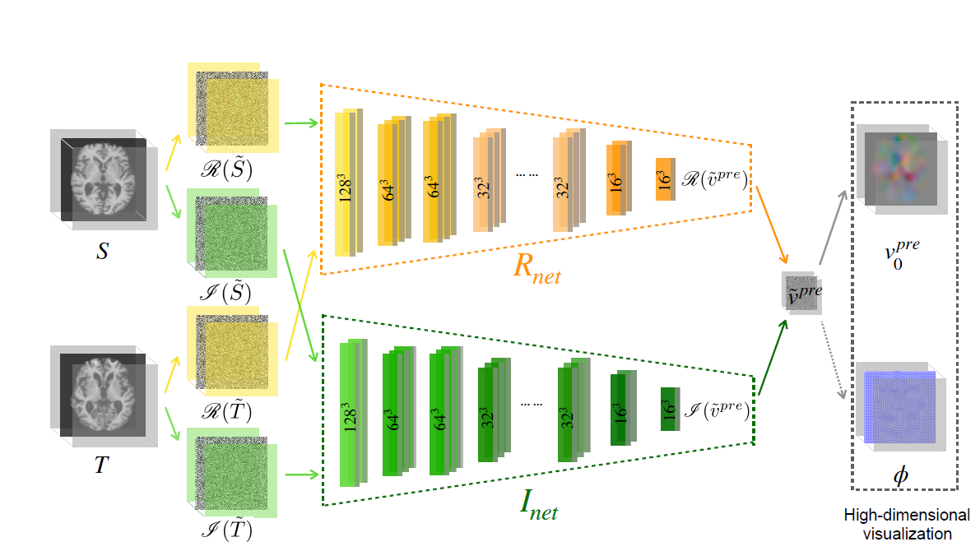

由作者的introduction部分可以得知，用**the low dimensional Fourier representations of diffeomorphic transformations取代高维度直接运算。**

优点非常明显的就是**our method dramatically reduces the computational complexity of the training process where iterative computation of gradient terms are required.**这个比较容易理解。

用the low dimensional Fourier representations of diffeomorphic transformations随之而来的问题就是如何定义一系列的复值运算和复值损失函数以及学习目标的问题。

第一个问题从网络中就可以看出构造了一个复值网络实部与虚部等价分离的双网络。





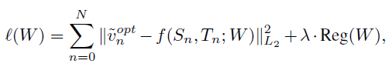

第二个问题：Our goal is then to predict an initial velocity vpre from image patches of the moving and target images. vopt作为最优由LDDMM计算的出,比较 vpre与vopt 对应loss函数第一项，第二项为正则项。

总结来说，1.对比常用的无监督配准网络，这种降维的网络运算在计算复杂度方面大大降低了，不论训练还是测试。2.在这基础上的解耦网络非常新颖，3.各种复值优化计算问题都是经过严格数学证明及推导。Experiment证明了这个方法在加速无监督配准上的前景。